Percentage Scrolled
Send Feedback

We will be making an amazing feature for a web page using JavaScript.

We have a gallery of images, which contains a large number of images and we want the user to keep watch on how much he had seen.

For this, we create a bar in the top right corner containing the percentage that denotes how much the document has been viewed/scrolled.

The gallery looks like this -
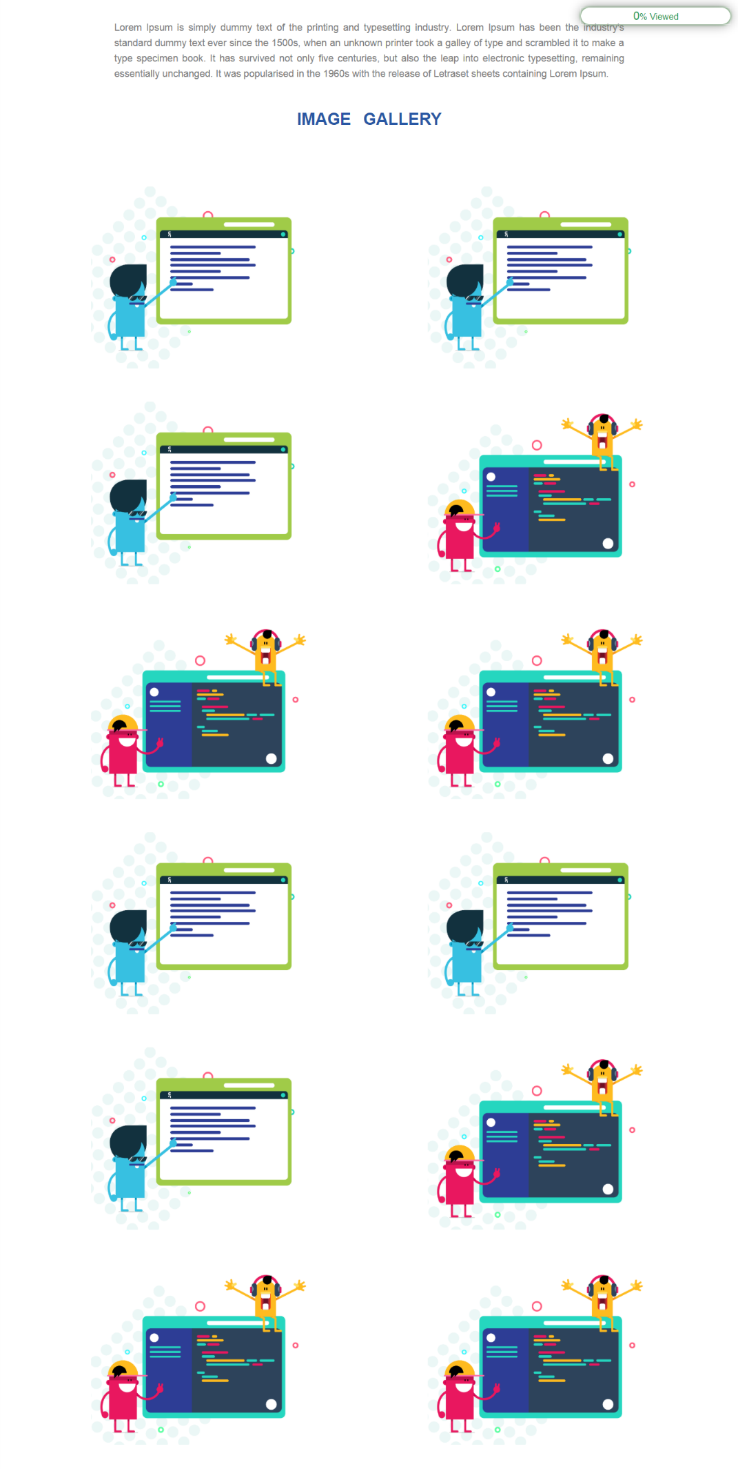

Gif for this problem is -


